**Name** : Dinesh Kumar R

**Company:** CODTECH IT SOLUTIONS

**Intern ID** : CT08DS6680

**Domain :** SQL

**Duration:** Augest to September 2024

**Mentor :** Muzammil Ahmed

**STUDENT DATABASE MANAGEMENT**

Creating a database to manage student records is a great way to practice relational database design and SQL queries. Below is a structured approach to designing the database, including table definitions and sample SQL queries.

**Database Design**

**1. Tables Overview :**

We'll create three main tables:

* **Students:** To store personal details of the students.
* **Courses:** To store information about the courses offered.
* **Enrollments:** To manage the relationship between students and courses, including grades.

**2. Table Definitions**

**Students Table :**

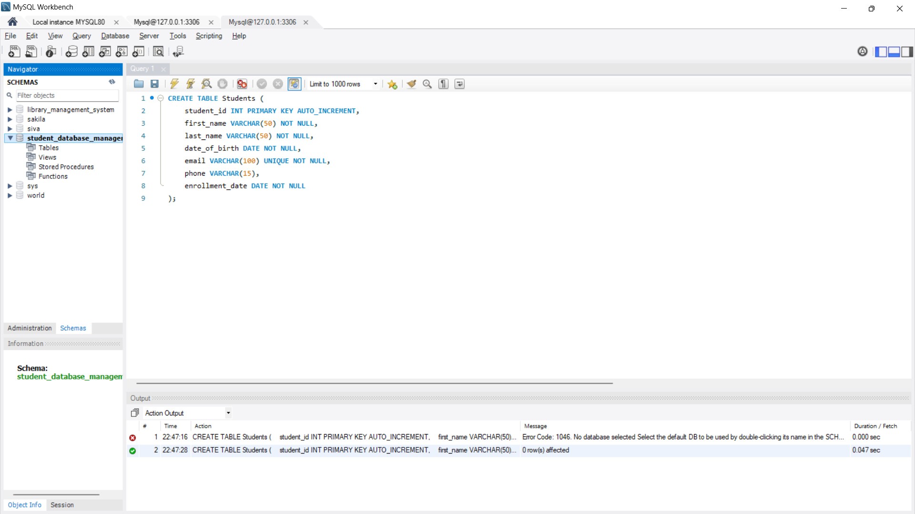

**Courses Table :**

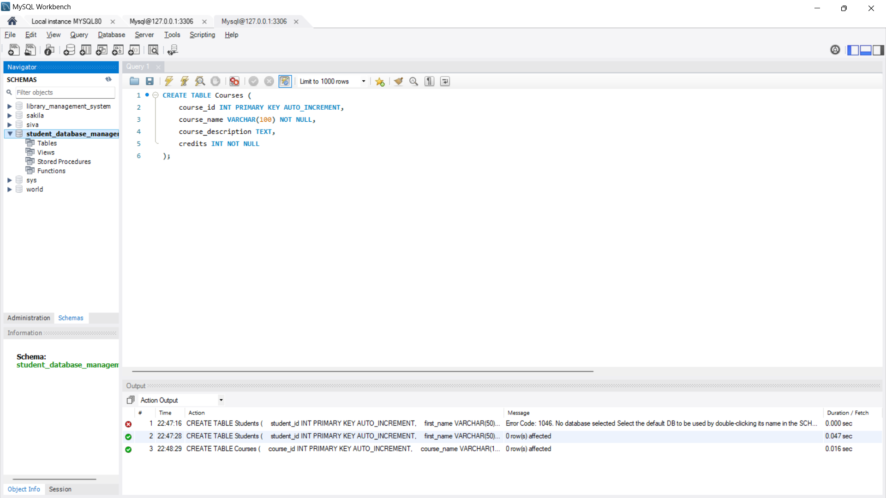

**Enrollments Table :**

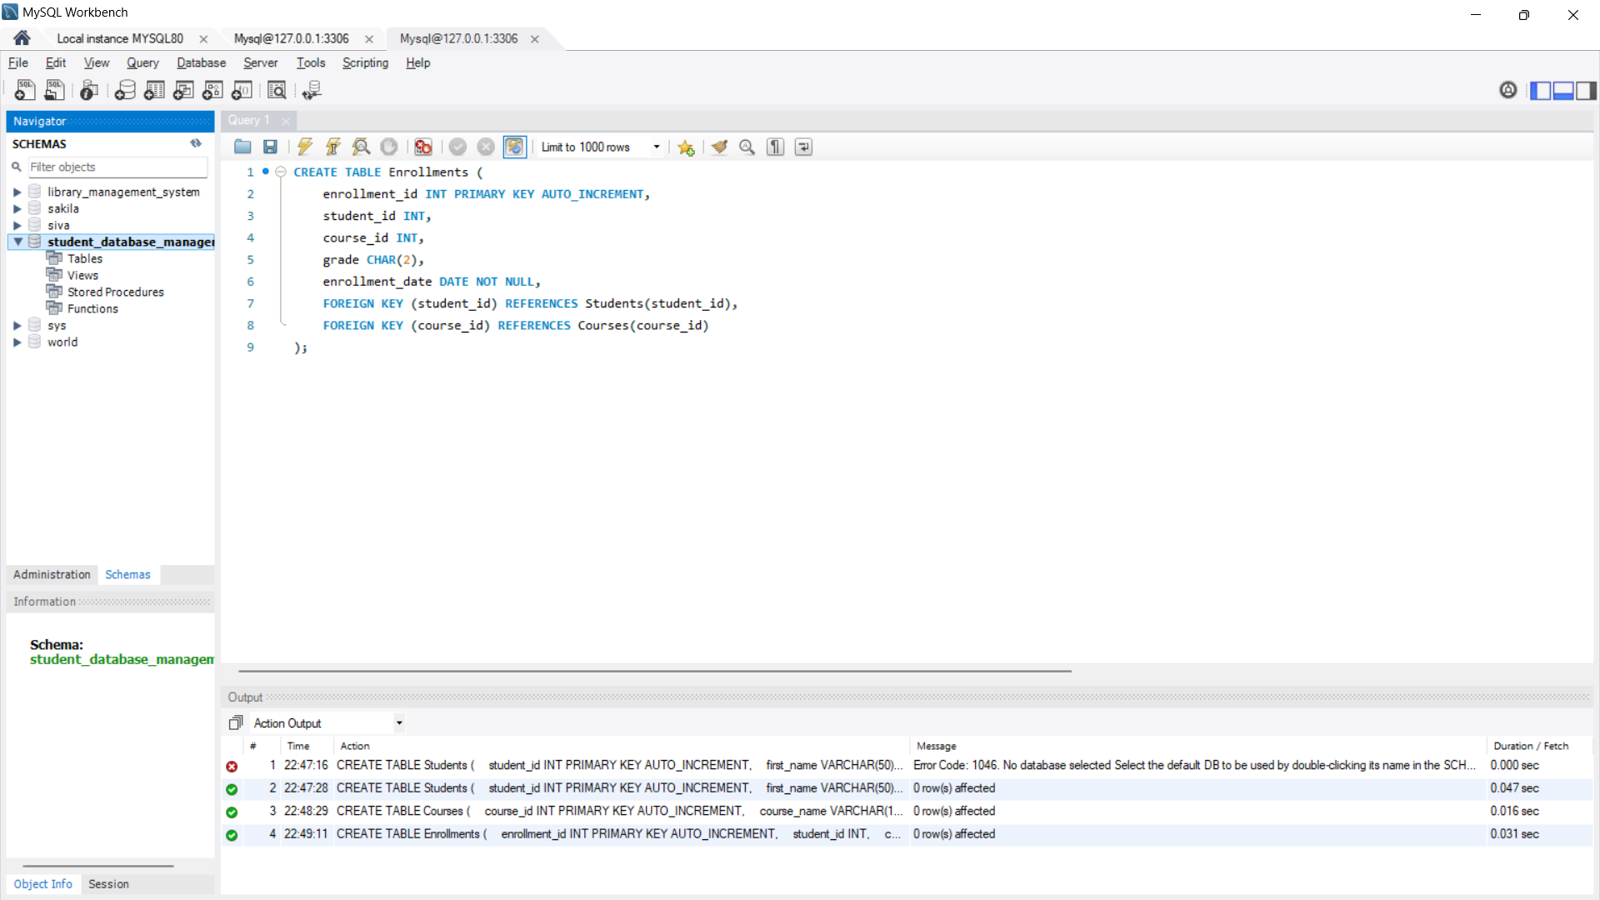

**To view the Table :**

**select * from Students;**

**select * from Courses;**

**select * from Enrollments;**

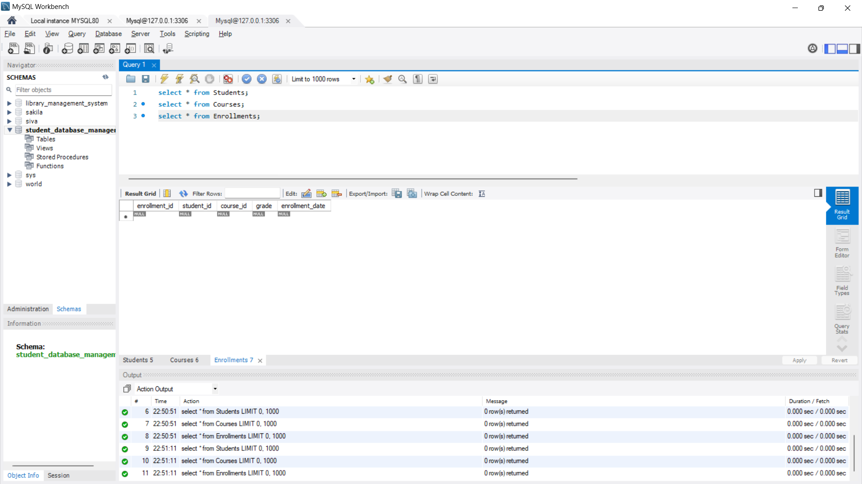

**Data Insertion :**

**Inserting Sample Data :**

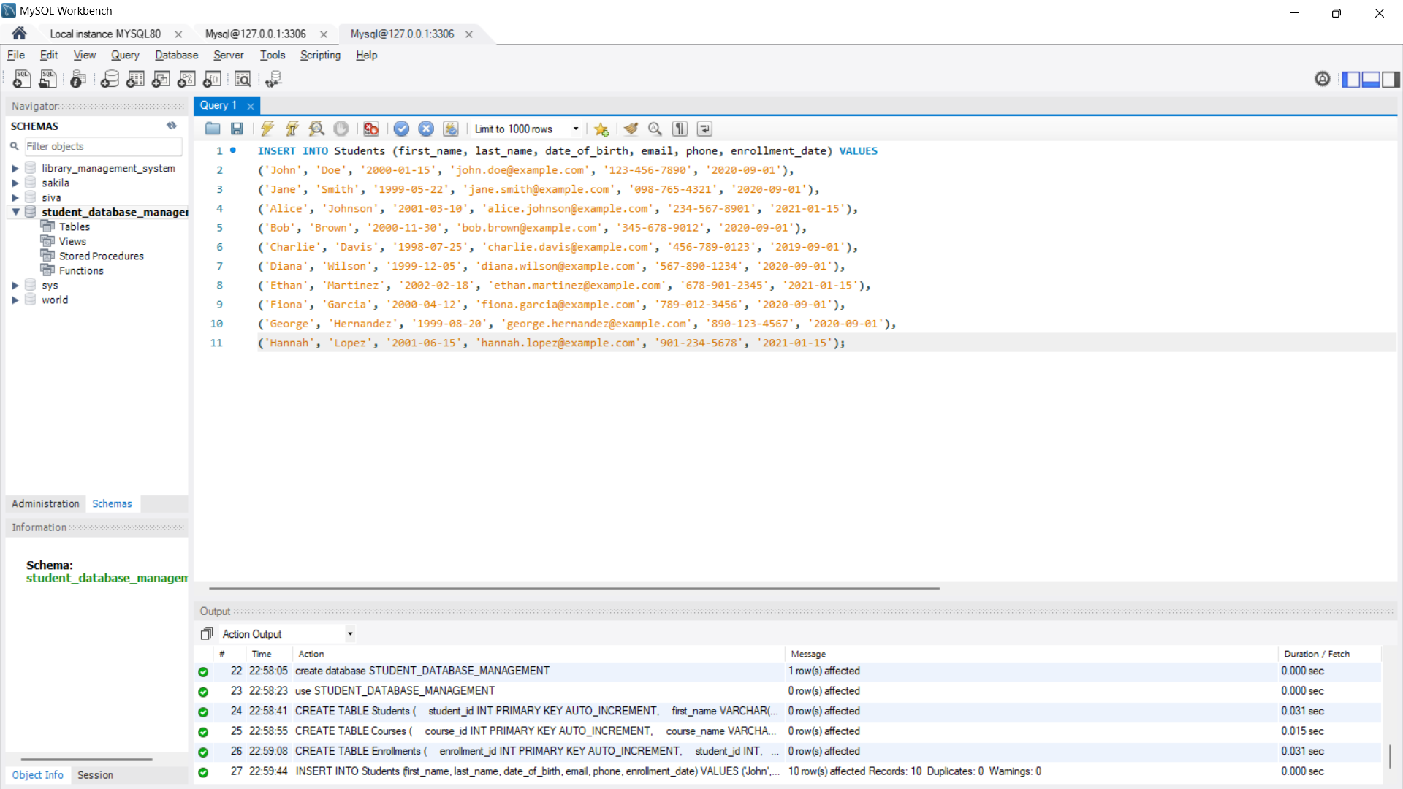

* **Students Table has been created.**

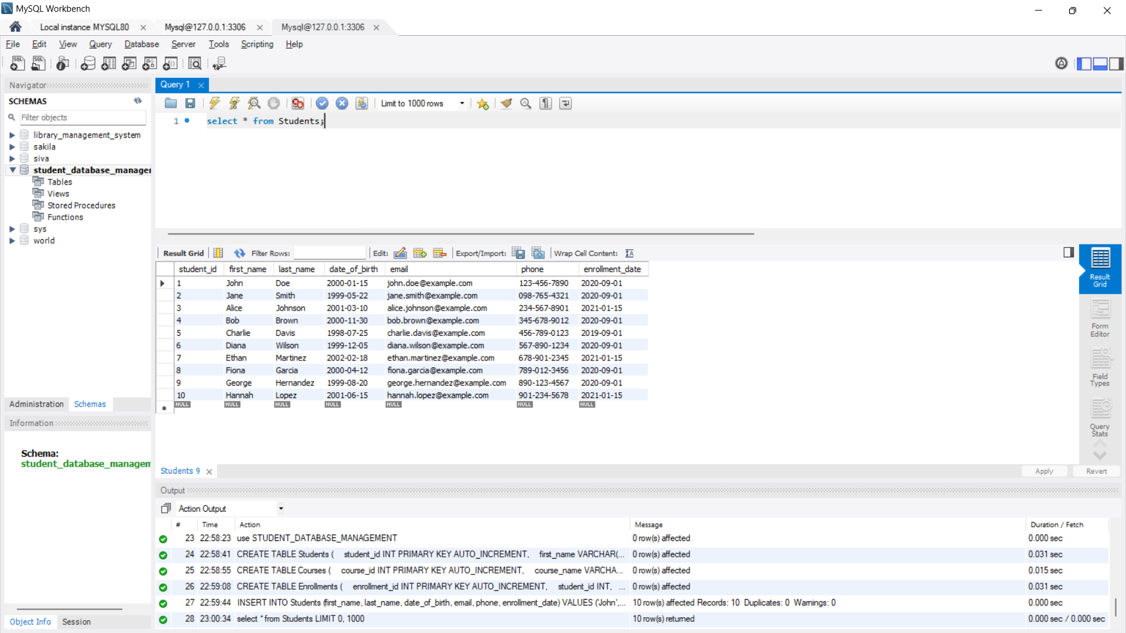

**Inserting Sample Courses:**

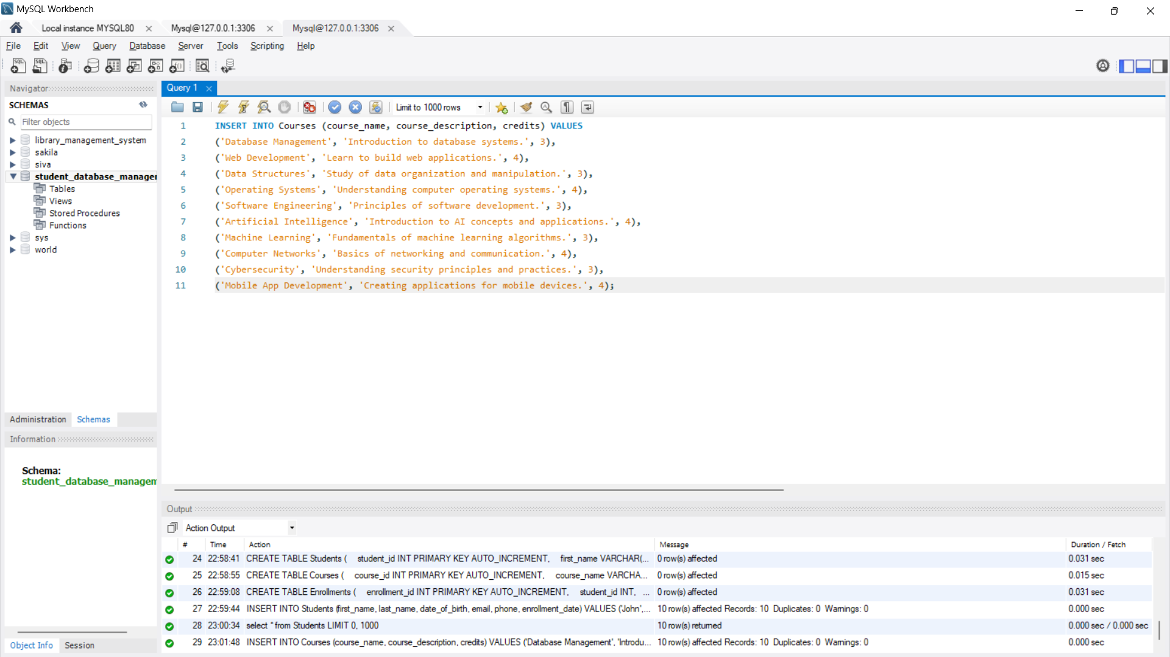

* **Courses Table has been created:**

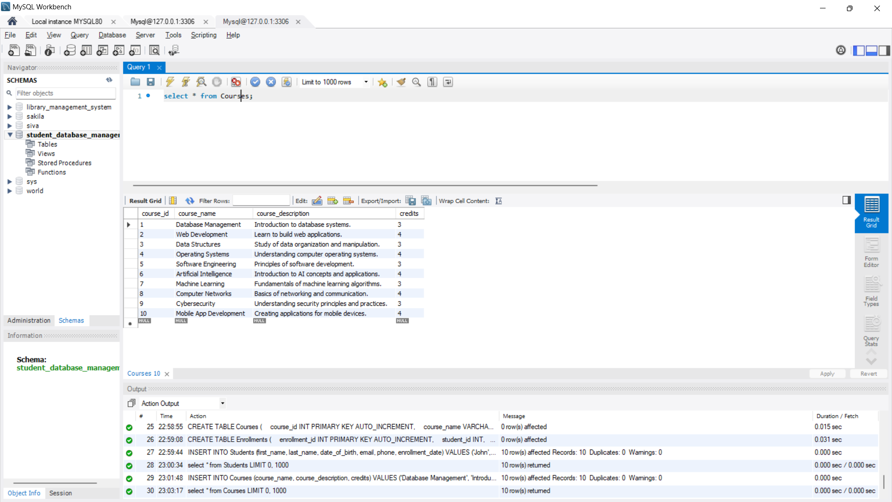

**Inserting Sample Enrollments :**

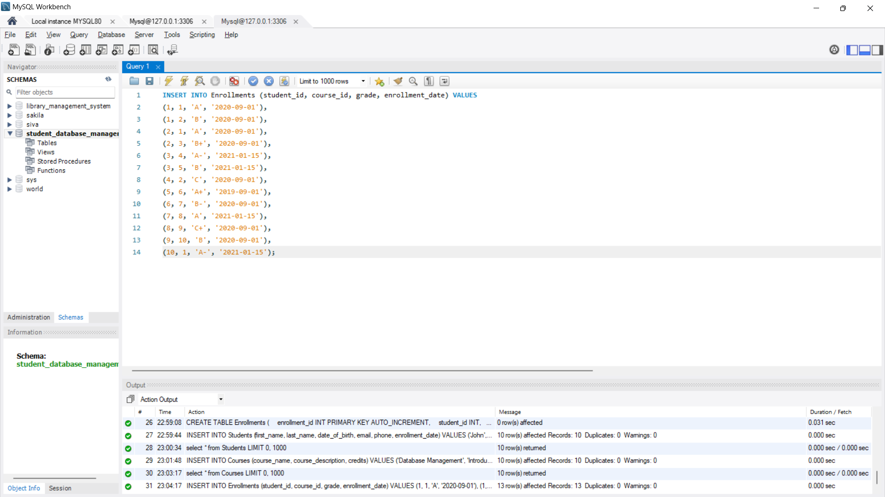

* **Enrollments Table has been created .**

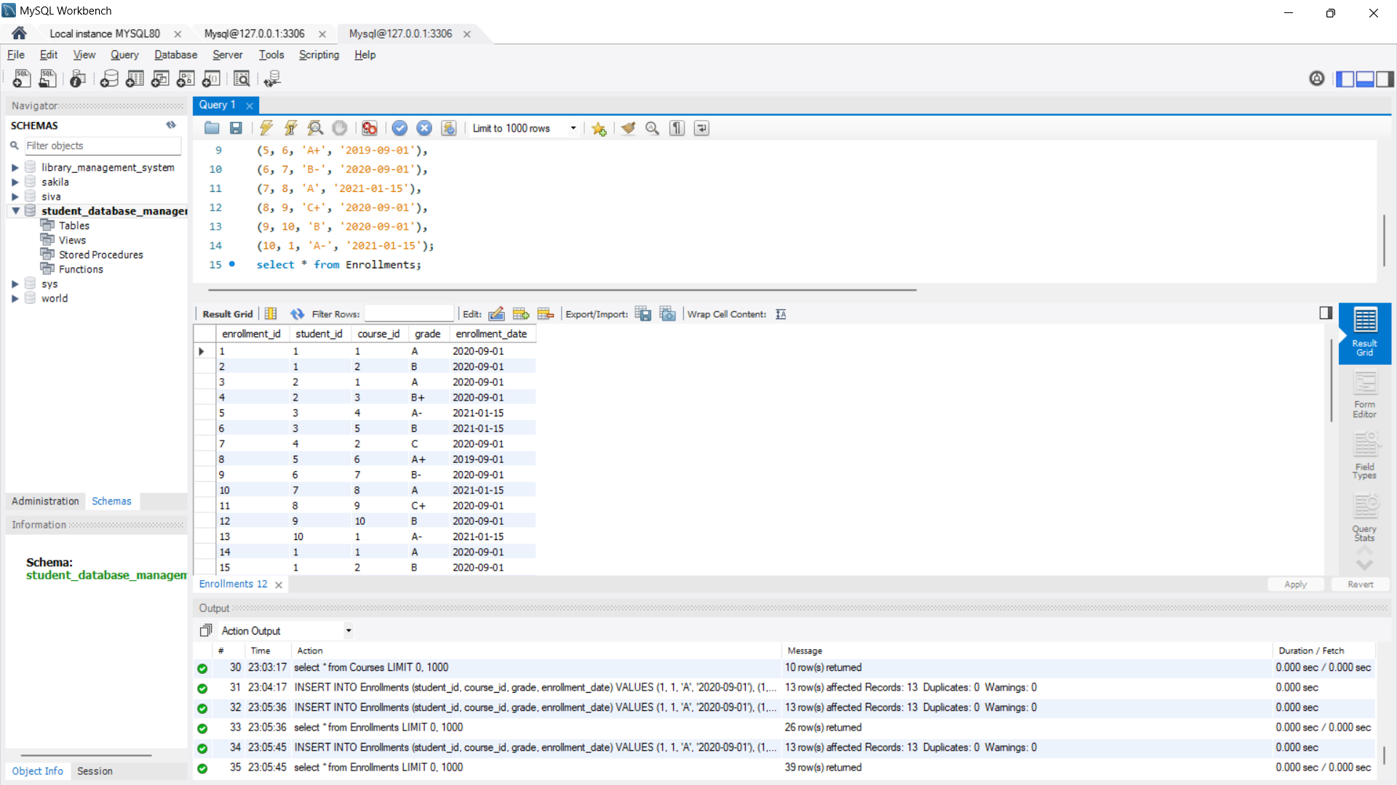

**SQL Queries**

**Retrieve All Students :**

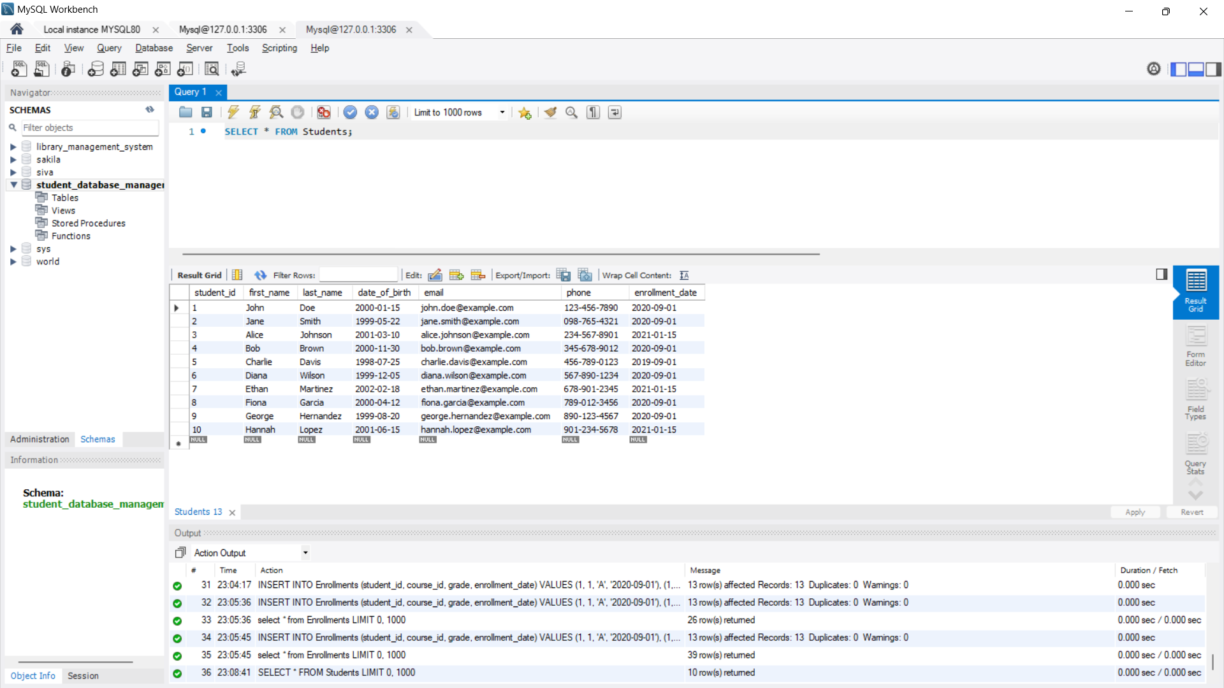

**Retrieve All Courses :**

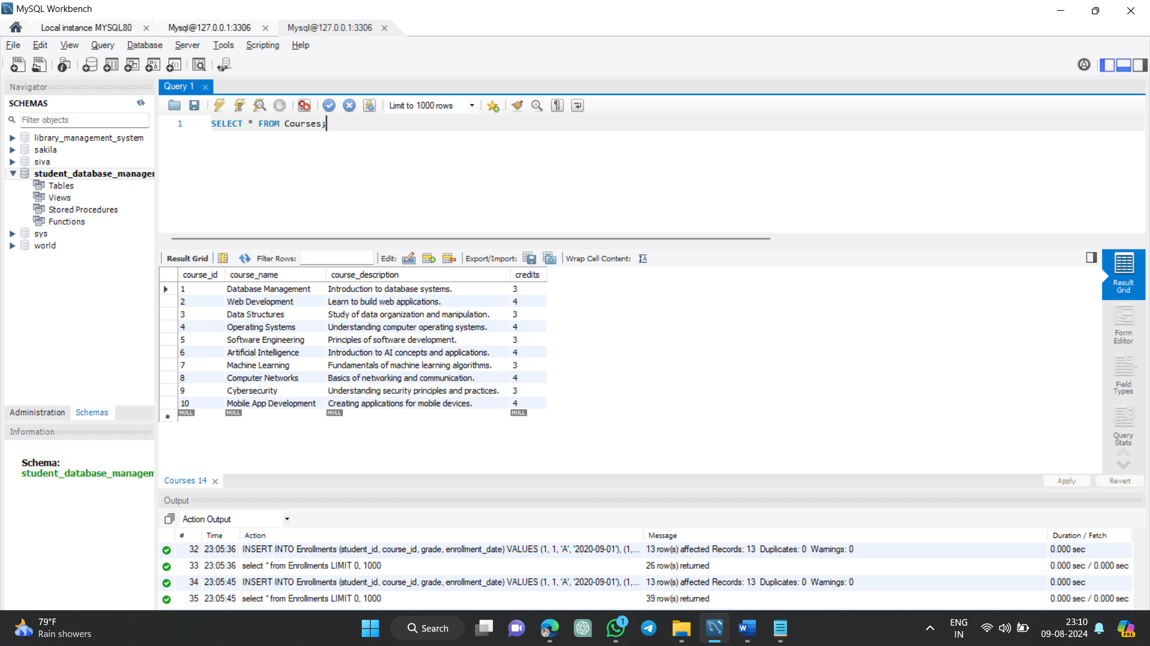

**Retrieve Enrollments with Student and Course Details :**

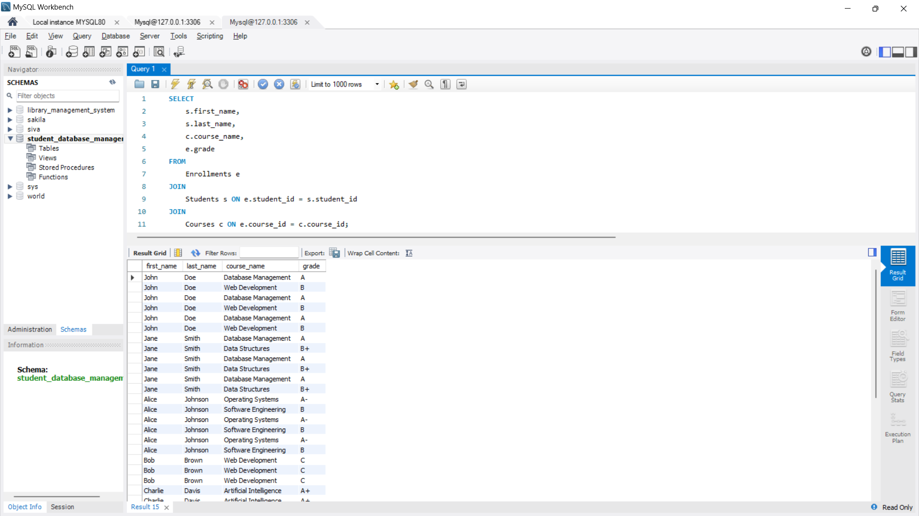

**Find Students Enrolled in a Specific Course :**

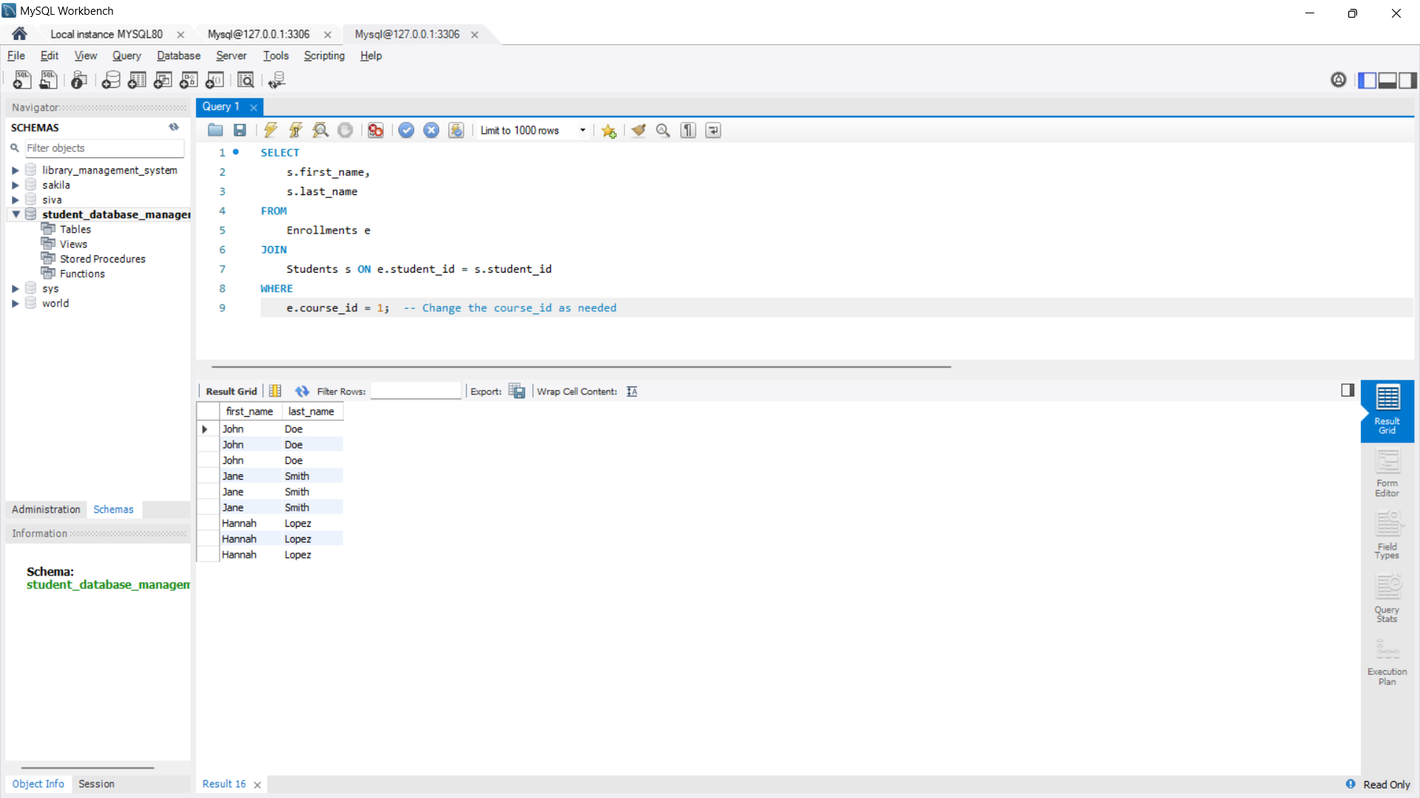

**Update a Student's Grade :**

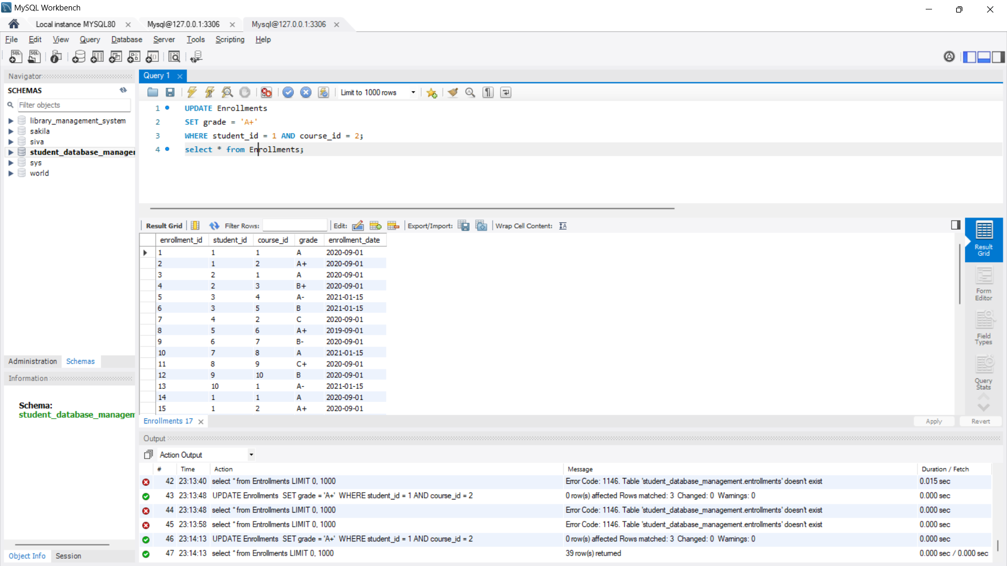

**Delete a Student Record :**

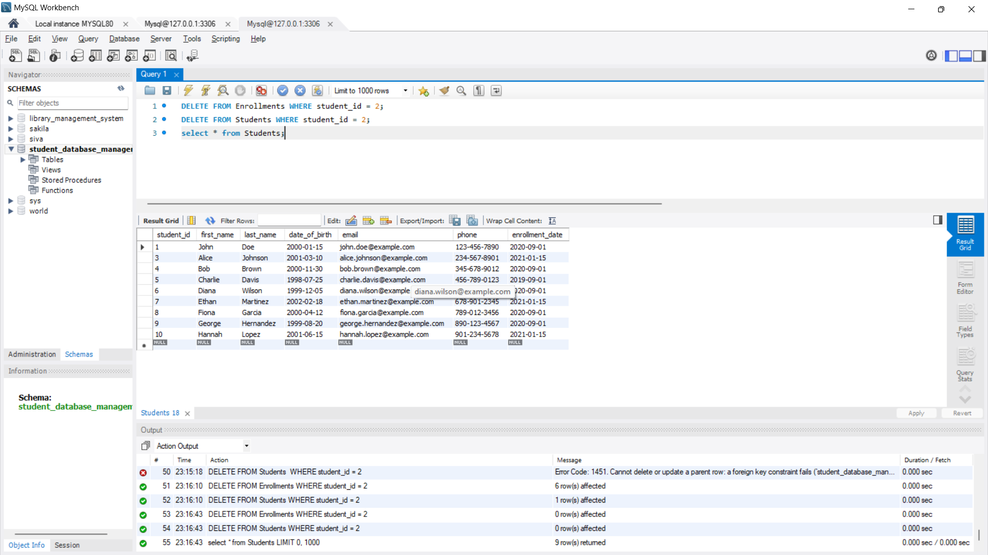

**Conclusion :**

**Student Database Management System (SDBMS) is essential for educational institutions to efficiently manage student records and streamline administrative processes. It centralizes data, improves accuracy, and enhances communication among students, faculty, and staff.**